**Unit - VI: Data Security in Cloud**

**Security Overview:**

# **What is cloud security?**

Preparing your business for future success starts with switching from on-premises hardware to the cloud for your computing needs. The cloud gives you access to more applications, improves data accessibility, helps your team collaborate more effectively, and provides easier content management. Some people may have reservations about switching to the cloud due to security concerns, but a reliable cloud service provider (CSP) can put your mind at ease and keep your data safe with highly secure cloud services.

Find out more about what cloud security is, the main types of cloud environments you'll need security for, the importance of cloud security, and its primary benefits.

## **Definition of cloud security**

Cloud security, also known as cloud computing security, is a collection of security measures designed to protect cloud-based infrastructure, applications, and data. These measures ensure user and device authentication, data and resource access control, and data privacy protection. They also support regulatory data compliance. Cloud security is employed in cloud environments to protect a company's data from distributed denial of service (DDoS) attacks, malware, hackers, and unauthorized user access or use.

## **Why is cloud security important?**

Cloud security is critical since most organizations are already using cloud computing in one form or another. This high rate of adoption of public cloud services is reflected in Gartner’s recent prediction that the worldwide market for public cloud services will grow [23.1% in 2021](https://www.gartner.com/en/newsroom/press-releases/2021-04-21-gartner-forecasts-worldwide-public-cloud-end-user-spending-to-grow-23-percent-in-2021).

IT professionals remain concerned about moving more data and applications to the cloud due to security, governance, and compliance issues when their content is stored in the cloud. They worry that highly sensitive business information and intellectual property may be exposed through accidental leaks or due to increasingly sophisticated cyber threats.

A crucial component of cloud security is focused on protecting data and business content, such as customer orders, secret design documents, and financial records. Preventing leaks and data theft is critical for maintaining your customers’ trust and protecting the assets that contribute to your competitive advantage. Cloud security's ability to guard your data and assets makes it crucial to any company switching to the cloud.

## **Cloud security benefits**

Security in cloud computing is crucial to any company looking to keep its applications and data protected from bad actors. Maintaining a strong cloud security posture helps organizations achieve the now widely recognized benefits of cloud computing. Cloud security comes with its own advantages as well, helping you achieve lower upfront costs, reduced ongoing operational and administrative costs, easier scaling, increased reliability and availability, and improved DDoS protection.

Here are the top security benefits of cloud computing:

### 

### ****1. Lower upfront costs****

One of the biggest advantages of using cloud computing is that you don't need to pay for dedicated hardware. Not having to invest in dedicated hardware helps you initially save a significant amount of moneyand can also help you upgrade your security. CSPs will handle your security needs proactively once you've hired them. This helps you save on costs and reduce the risks associated with having to hire an internal security team to safeguard dedicated hardware.

### 

### ****2. Reduced ongoing operational and administrative expenses****

Cloud security can also lower your ongoing administrative and operational expenses. A CSP will handle all your security needs for you, removing the need to pay for staff to provide manual security updates and configurations. You can also enjoy greater security, as the CSP will have expert staff able to handle any of your security issues for you.

### ****3. Increased reliability and availability****

You need a secure way to immediately access your data. Cloud security ensures your data and applications are readily available to authorized users. You'll always have a reliable method to access your cloud applications and information, helping you quickly take action on any potential security issues.

### 4. Centralized security

Cloud computing gives you a centralized location for data and applications, with many endpoints and devices requiring security. Security for cloud computing centrally manages all your applications, devices, and data to ensure everything is protected. The centralized location allows cloud security companies to more easily perform tasks, such as implementing disaster recovery plans, streamlining network event monitoring, and enhancing web filtering.

### 5. Greater ease of scaling

Cloud computing allows you to scale with new demands, providing more applications and data storage whenever you need it. Cloud security easily scales with your cloud computing services. When your needs change, the centralized nature of cloud security allows you to easily integrate new applications and other features without sacrificing your data's safety. Cloud security can also scale during high traffic periods, providing more security when you upgrade your cloud solution and scaling down when traffic decreases.

### 6. Improved DDoS protection

Distributed Denial of Service (DDoS) attacks are some of the biggest threats to cloud computing. These attacks aim a lot of traffic at servers at once to cause harm. Cloud security protects your servers from these attacks by monitoring and dispersing them.

**Cloud Security challenges and risks**

Common cloud security challenges:

1. data breaches
2. misconfigurations and inadequate change control
3. lack of cloud security architecture and strategy
4. insufficient identity, credential, access and key management
5. account hijacking
6. insider threats
7. insecure interfaces and APIs
8. weak control plane
9. metastructure and applistructure failures
10. limited cloud usage visibility
11. abuse and nefarious use of cloud services

### 1. Data breaches

A responsibility of both CSPs and their customers, data breaches remained the top cloud security threat yet again this year in CSA's report. A number of data breaches have been attributed to the cloud over the past years, one of the most notable being [Capital One's cloud misconfigurations](https://www.techtarget.com/searchaws/feature/What-AWS-users-can-learn-from-the-Capital-One-breach).

A data breach can bring a company to its knees, causing irreversible damage to its reputation, financial woes due to regulatory implications, legal liabilities, [incident response](https://www.techtarget.com/searchsecurity/Ultimate-guide-to-incident-response-and-management) costs and decreased market value.

CSA recommended the following:

* defining data value and the impact of its loss;
* protecting data via encryption; and
* Having a strong, well-tested incident response plan.

CSA Cloud Controls Matrix (CCM) specifications (see "CSA Cloud Controls Matrix" sidebar for more info) include the following:

* performing data input and output integrity routines;
* applying the principle of least privilege to access control; and
* Establishing policies and procedures for secure data removal and disposal.

### 2. Misconfigurations and inadequate change control

When assets are set up incorrectly, they are vulnerable to attack. For example, the Capital One breach was traced back to a web application firewall misconfiguration that exposed Amazon S3 buckets. In addition to insecure storage, excessive permissions and the use of default credentials are two other major sources of vulnerabilities.

Related to this, ineffective change control can cause cloud misconfigurations. In on-demand, real-time cloud environments, change control should be automated to support rapid change.

A responsibility of the customer, misconfigurations and change control are new to the cloud security threat list.

CSA recommended the following:

* paying special attention to data accessible via the internet;
* defining the business value of data and the impact of its loss; and
* creating and maintaining a strong incident response plan.

CCM specifications include the following:

* ensuring external partners adhere to the change management, release and testing procedures used by internal developers;
* conducting risk assessments at planned intervals; and
* performing security awareness training with contractors, third-party users and employees.

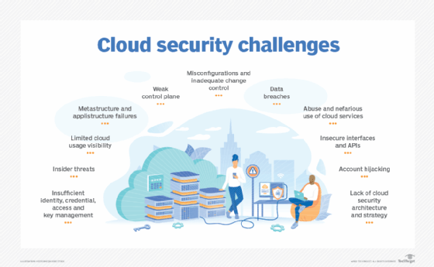

### 3. Lack of cloud security architecture and strategy

Too many organizations jump into the cloud without the proper architecture and strategy in place. Prior to making the leap to the cloud, customers must understand the threats they are exposed to, how to migrate to the cloud securely -- note, it's not a lift-and-shift process -- and the ins and outs of the shared responsibility model.

This threat is new to the list and is a responsibility of the customer. Without proper planning, customers will be vulnerable to [cyber-attacks](https://www.techtarget.com/searchsecurity/definition/cyber-attack) that can result in financial losses, reputational damage, and legal and compliance issues.

CSA recommended the following:

* ensuring the security architecture aligns with business goals and objectives;
* developing and implementing a security architecture framework; and
* implementing continuous security monitoring procedures.

CCM specifications include the following:

* ensuring risk assessment policies include updating policies, procedures, standards and controls to remain relevant;
* designing, developing and deploying business-critical/customer-impacting application and API designs and configurations and network and system components in accordance with agreed-upon service-level and capacity-level expectations, IT governance, and service management policies and procedures; and
* Restricting and monitoring traffic between trusted and untrusted connections in network environments and virtual instances.

### 4. Insufficient identity, credential, access and key management

A majority of cloud security threats -- and cybersecurity threats in general -- can be linked to identity and access management (IAM) issues. According to CSA guidance, this stems from the following:

* improper credential protection
* lack of automated cryptographic key, password and certificate rotation
* IAM scalability challenges
* absence of multifactor authentication
* weak passwords

New to the top cloud security challenges list, standard IAM challenges are exacerbated by cloud use. Conducting inventory, tracking, monitoring and managing the sheer number of cloud accounts needed is compounded by provisioning and deprovisioning issues, zombie accounts, excessive admin accounts and users bypassing IAM controls, as well as challenges with defining roles and privileges.

As a customer responsibility, CSA recommended the following:

* using two-factor authentication;
* practicing strict IAM controls for cloud users and identities;
* rotating keys, removing unused credentials and access privileges, and employing central, programmatic key management.

CCM specifications include the following:

* identifying key managers and creating and maintaining key management policies;
* assigning, documenting and communicating the roles and responsibilities for performing employment termination or procedure changes; and
* Performing timely deprovisioning -- whether revocation or modification -- of user access to data and network components.

### 5. Account hijacking

Cloud account hijacking is the disclosure, accidental leakage, exposure or other compromise of a cloud account that is critical to the operation, administration or maintenance of a cloud environment. These highly privileged and sensitive accounts, if breached, can cause massive consequences.

From phishing and credential stuffing to weak or stolen credentials to improper coding, account compromise can lead to data breaches and service disruptions.

A responsibility of CSPs and customers, CSA recommended the following:

* remembering that account hijacking isn't just a password reset; and
* Using defense-in-depth and IAM controls.

CCM specifications include the following:

* establishing, documenting and adopting a unified business continuity plan;
* separating production and nonproduction environments; and
* Maintaining and regularly updating compliance liaisons in preparation for a forensic investigation requiring rapid engagement with law enforcement.

### 6. Insider threats

The risks associated with employees and others working within an organization's network are not limited to the cloud. Whether negligent or intentional, insiders -- including current and former employees, contractors and partners -- can cause data loss, system downtime, reduced customer confidence and data breaches.

A responsibility of the customer, insider threats involving leaked or stolen data, credential issues, human errors and cloud misconfigurations must be addressed.

CSA recommended the following:

* conducting security awareness training;
* fixing misconfigured cloud servers; and
* Restricting access to critical systems.

CCM specifications include the following:

* requiring authorization prior to relocating or transferring hardware, software or data;
* authorizing and revalidating user access controls at planned intervals; and
* Segmenting multi-tenant apps, infrastructure and networks from other tenants.

### 7. Insecure interfaces and APIs

CSP UIs and APIs through which customers interact with cloud services are some of the most exposed components of a cloud environment. The security of any cloud service starts with how well these are safeguarded and is the responsibility of both customers and CSPs.

CSPs must ensure security is integrated, and customers must be diligent in managing, monitoring and securely using what CSA calls the "front door" of the cloud. This threat dropped from the third most important in the last report but is still important to address.

CSA recommended the following:

* practicing good API hygiene;
* avoiding API key reuse; and
* using standard and open API frameworks.

CCM specifications include the following:

* designing, developing, deploying and testing APIs in accordance with industry leading standards, as well as adhering to applicable legal, statutory and regulatory obligations;
* segregating and restricting access to audit tools that interact with the organization's information systems to prevent data disclosure and tampering; and
* restricting utility programs capable of overriding system, object, network, VM and application controls.

### 8. Weak control plane

A responsibility of the customer and new to the list this year, the [cloud control plane](https://searchcloudsecurity.techtarget.com/tip/5-steps-to-a-secure-cloud-control-plane) is the collection of cloud administrative consoles and interfaces used by an organization. It also includes data duplication, migration and storage, according to CSA. Improperly secured, a breached control plane could cause data loss, regulatory fines and other consequences, as well as a tarnished brand reputation that could lead to revenue loss.

CSA recommended the following:

* requiring adequate controls from CSPs; and
* performing due diligence to determine if potential cloud services have adequate control planes.

CCM specifications include the following:

* establishing and making infosec policies and procedures readily available for review by internal personnel and external business relationships;
* implementing and applying defense-in-depth measures to detect and respond to network-based attacks in a timely manner; and
* establishing policies to label, handle and secure data and objects that contain data.

### 9. Metastructure and applistructure failures

The metastructure, defined by CSA, is "the protocols and mechanisms that provide the interface between the infrastructure layer and other layers" -- in other words, "the glue that ties the technologies and enables management and configuration."

Also known as the waterline, the metastructure is the line of demarcation between CSPs and customers. Many security threats exist here -- for example, CSA cited poor API implementation by CSPs or improper cloud app use by customers. Such security challenges could lead to service disruption and misconfigurations with financial and data loss consequences.

The applistructure is defined as "the applications deployed in the cloud and the underlying application services used to build them -- for example, PaaS features like message queues, AI analysis or notification services."

A new threat this report, it is a customer and CSP responsibility. CSA recommended the following:

* CSPs offering visibility and exposing mitigations to counteract their tenants' lack of transparency;
* CSPs conducting [penetration testing](https://www.techtarget.com/searchsecurity/definition/penetration-testing) and providing findings to customers; and
* customers implementing features and controls in cloud-native designs.

CCM specifications include the following:

* developing and maintaining audit plans to address business process disruptions;
* implementing encryption to [protect data in storage, in use and in transit](https://www.techtarget.com/searchsecurity/feature/Best-practices-to-secure-data-at-rest-in-use-and-in-motion); and
* establishing policies and procedures to store and manage identity information.

### 10. Limited cloud usage visibility

Cloud visibility has long been a concern of enterprise admins, but it is new to the CSA cloud security challenges list this report. Limited visibility results in two key challenges, according to CSA:

1. Unsanctioned app use, also known as [*shadow IT*](https://www.techtarget.com/searchcloudcomputing/definition/shadow-IT-shadow-information-technology), is when employees use applications not permitted by IT.
2. Sanctioned app misuse is when apps approved by IT are not used as intended. This includes users authorized to use the app, as well as unauthorized individuals accessing it with stolen credentials obtained via SQL injection or DNS attacks, for example.

This limited visibility, CSA said, leads to lack of governance, awareness and security -- all of which can result in cyber attacks, data loss and breaches.

New to the list this year, it is a responsibility of CSPs and customers. CSA recommended the following:

* developing a cloud visibility effort from the top down;
* mandating and enforcing companywide training on [acceptable cloud usage policies](https://searchcloudsecurity.techtarget.com/tip/How-to-create-a-cloud-security-policy-step-by-step); and
* requiring all nonapproved cloud services be reviewed and approved by a cloud security architect or third-party risk management.

CCM specifications include the following:

* conducting risk assessments at regular intervals;
* making all personnel aware of their compliance and security roles and responsibilities; and
* [conducting inventories, documenting and maintaining data flows](https://www.techtarget.com/searchsecurity/feature/How-to-keep-track-of-sensitive-data-with-a-data-flow-map).

### 11. Abuse and nefarious use of cloud services

Just as the cloud can be used for good, it can also be used maliciously by threat actors. Nefarious use of legitimate SaaS, PaaS and IaaS offerings affects individuals, cloud customers and CSPs alike. Disguised as coming from a CSP, customers are especially vulnerable to the misuse of cloud services via the following:

* distributed denial-of-service attacks
* phishing
* cryptomining
* click fraud
* brute-force attacks
* hosted malicious or pirated content

Compromised and abused cloud services can lead to incurred expenses -- for example, loss in cryptocurrency or payments made by the attacker; the customer unknowingly hosting malware; data loss; and more.

CSA recommended CSPs be diligent in detecting and mitigating such attacks with an incident response framework. CSPs should also offer tools and controls their customers can use to [monitor cloud workloads and applications](https://searchcloudsecurity.techtarget.com/tip/Cloud-workload-protection-platform-security-benefits-features).

A customer and CSP responsibility, CSA recommended the following:

* monitoring employee cloud use; and
* using cloud data loss prevention technologies.

CCM specifications include the following:

* adopting technical measures to manage mobile device risks;
* defining allowances and usage permissions for enterprise- and user-owned endpoints, including workstations, laptops and mobile devices; and
* creating and maintaining a list of approved applications and application stores.

**Cloud Computing Security architecture**

The **Cloud Security Alliance (CSA)** stack model defines the boundaries between each service model and shows how different functional units relate. A particular service model defines the boundary between the service provider's responsibilities and the customer. The following diagram shows the **CSA stack model:**

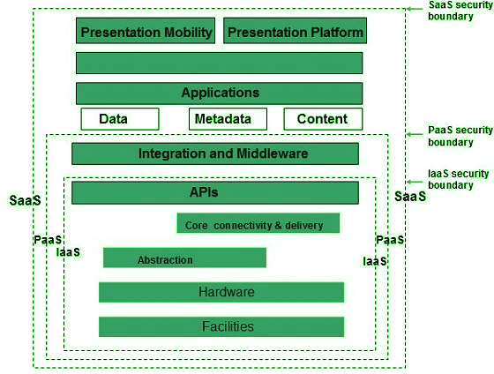

Key Points to CSA Model

* IaaS is the most basic level of service, with PaaS and SaaS next two above levels of services.
* Moving upwards, each service inherits the capabilities and security concerns of the model beneath.
* IaaS provides the infrastructure, PaaS provides the platform development environment, and SaaS provides the operating environment.
* IaaS has the lowest integrated functionality and security level, while SaaS has the highest.
* This model describes the security boundaries at which cloud service providers' responsibilities end and customers' responsibilities begin.
* Any protection mechanism below the security limit must be built into the system and maintained by the customer.

Although each service model has a security mechanism, security requirements also depend on where these services are located, private, public, hybrid, or community cloud.

Understanding data security

Since all data is transferred using the Internet, data security in the cloud is a major concern. Here are the key mechanisms to protect the data.

* access control
* audit trail
* certification
* authority

The service model should include security mechanisms working in all of the above areas.

Separate access to data

Since the data stored in the cloud can be accessed from anywhere, we need to have a mechanism to isolate the data and protect it from the client's direct access.

**Broker cloud storage** is a way of separating storage in the Access Cloud. In this approach, two services are created:

1. A broker has full access to the storage but does not have access to the client.
2. A proxy does not have access to storage but has access to both the client and the broker.
3. Working on a Brocade cloud storage access system
4. When the client issues a request to access data:
5. The client data request goes to the external service interface of the proxy.
6. The proxy forwards the request to the broker.
7. The broker requests the data from the cloud storage system.
8. The cloud storage system returns the data to the broker.
9. The broker returns the data to the proxy.
10. Finally, the proxy sends the data to the client.

**All the above steps are shown in the following diagram:**

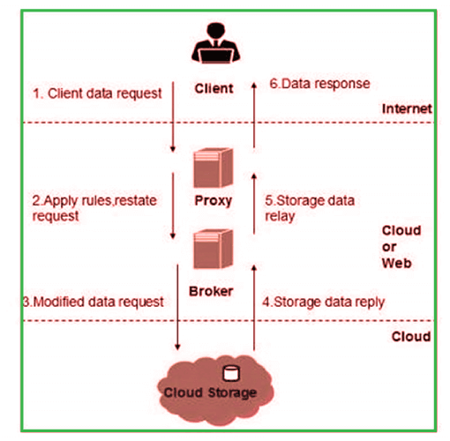

Encoding

Encryption helps to protect the data from being hacked. It protects the data being transferred and the data stored in the cloud. Although encryption helps protect data from unauthorized access, it does not prevent data loss.

Why is cloud security architecture important?

The difference between "cloud security" and "cloud security architecture" is that the former is built from problem-specific measures while the latter is built from threats. A cloud security architecture can reduce or eliminate the holes in Security that point-of-solution approaches are almost certainly about to leave.

It does this by building down - defining threats starting with the users, moving to the cloud environment and service provider, and then to the applications. Cloud security architectures can also reduce redundancy in security measures, which will contribute to threat mitigation and increase both capital and operating costs.

The cloud security architecture also organizes security measures, making them more consistent and easier to implement, particularly during cloud deployments and redeployments. Security is often destroyed because it is illogical or complex, and these flaws can be identified with the proper cloud security architecture.

Elements of cloud security architecture

The best way to approach cloud security architecture is to start with a description of the goals. The architecture has to address three things: an attack surface represented by external access interfaces, a protected asset set that represents the information being protected, and vectors designed to perform indirect attacks anywhere, including in the cloud and attacks the system.

The goal of the cloud security architecture is accomplished through a series of functional elements. These elements are often considered separately rather than part of a coordinated architectural plan. It includes access security or access control, network security, application security, contractual Security, and monitoring, sometimes called service security. Finally, there is data protection, which are measures implemented at the protected-asset level.

A complete cloud security architecture addresses the goals by unifying the functional elements.

Cloud security architecture and shared responsibility model

The security and security architectures for the cloud are not single-player processes. Most enterprises will keep a large portion of their IT workflow within their data centers, local networks, and VPNs. The cloud adds additional players, so the cloud security architecture should be part of a broader shared responsibility model.

A shared responsibility model is an architecture diagram and a contract form. It exists formally between a cloud user and each cloud provider and network service provider if they are contracted separately.

Each will divide the components of a cloud application into layers, with the top layer being the responsibility of the customer and the lower layer being the responsibility of the cloud provider. Each separate function or component of the application is mapped to the appropriate layer depending on who provides it. The contract form then describes how each party responds.

**Virtual Machine Security in Cloud**

**What is virtualized security?**

Virtualized security, or security virtualization, refers to security solutions that are software-based and designed to work within a virtualized IT environment. This differs from traditional, hardware-based network security, which is static and runs on devices such as traditional firewalls, routers, and switches.

In contrast to hardware-based security, virtualized security is flexible and dynamic. Instead of being tied to a device, it can be deployed anywhere in the network and is often cloud-based. This is key for virtual machine security in cloud computing, in which operators spin up workloads and applications dynamically; virtualized security allows security services and functions to move around with those dynamically created workloads.

Virtual machine security in cloud computing mechanisms such as isolating multitenant environments in public cloud environments is also important to virtualized security. The flexibility of virtualized security is helpful for securing hybrid and multi-cloud environments, where data and workloads migrate around a complicated ecosystem involving multiple vendors.

**What are the benefits of virtualized security?**

Virtualized security is now effectively necessary to keep up with the complex security demands of a virtualized network, plus it’s more flexible and efficient than traditional physical security.

Here are some of its specific benefits:

**Cost-effectiveness:** Virtual machine security in cloud computing allows an enterprise to maintain a secure network without a large increase in spending on expensive proprietary hardware. Pricing for cloud-based virtualized security services is often determined by usage, which can mean additional savings for organizations that use resources efficiently.

**Flexibility:** Virtualized security functions can follow workloads anywhere, which is crucial in a virtualized environment. It provides protection across multiple data centres and in multi-cloud and hybrid cloud environments, allowing an organization to take advantage of the full benefits of virtualization while also keeping data secure.

**Operational efficiency:** Quicker and easier to deploy than hardware-based security, virtualized security doesn’t require IT, teams, to set up and configure multiple hardware appliances. Instead, they can set up security systems through centralized software, enabling rapid scaling. Using software to run security technology also allows security tasks to be automated, freeing up additional time for IT teams.

**Regulatory compliance:** Traditional hardware-based security is static and unable to keep up with the demands of a virtualized network, making virtual machine security in cloud computing, a necessity for organizations that need to maintain regulatory compliance.

**Identity management and access control**

There is a saying in the [cybersecurity](https://www.geeksforgeeks.org/cyber-safety/) world that goes like this “No matter how good your chain is it’s only as strong as your weakest link.” and exactly hackers use the weakest links in the organization to infiltrate. They usually use phishing attacks to infiltrate an organization and if they get at least one person to fall for it, it’s a serious turn of events from thereon. They use the stolen credentials to plant back doors, install malware or exfiltrate confidential data, all of which will cause serious losses for an organization. And so [Identity and Access Management (IAM)](https://www.geeksforgeeks.org/identity-and-access-management-iam/) is a combination of policies and technologies that allows organizations to identify users and provide the right form of access as and when required. There has been a burst in the market with new applications, and the requirement for an organization to use these applications has increased drastically. The services and resources you want to access can be specified in IAM. IAM doesn’t provide any replica or backup.  IAM can be used for many purposes such as, if one want’s to control access of individual and group access for your AWS resources. With IAM policies, managing permissions to your workforce and systems to ensure least-privilege permissions becomes easier. The AWS IAM is a global service.

**Components of IAM**

* Users
* Roles
* Groups
* Policies

 With these new applications being created over the cloud, mobile and on-premise can hold sensitive and regulated information. It’s no longer acceptable and feasible to just create an Identity server and provide access based on the requests. In current times an organization should be able to track the flow of information and provide least privileged access as and when required, obviously with a large workforce and new applications being added every day it becomes quite difficult to do the same. So organizations specifically concentrate on managing identity and its access with the help of a few IAM tools. It’s quite obvious that it is very difficult for a single tool to manage everything but there are multiple IAM tools in the market that help the organizations with any of the few services given below.

**Services By IAM**

* Identity management
* Access management
* Federation
* [RBAC/EM](https://www.geeksforgeeks.org/role-based-access-control/)
* Multi-Factor authentication
* Access governance
* Customer IAM
* API Security
* [IDaaS – Identity as a service](https://www.geeksforgeeks.org/identity-as-a-service-idaas-as-a-cloud-based-service/)
* Granular permissions
* Privileged Identity management – PIM (PAM or PIM is the same)

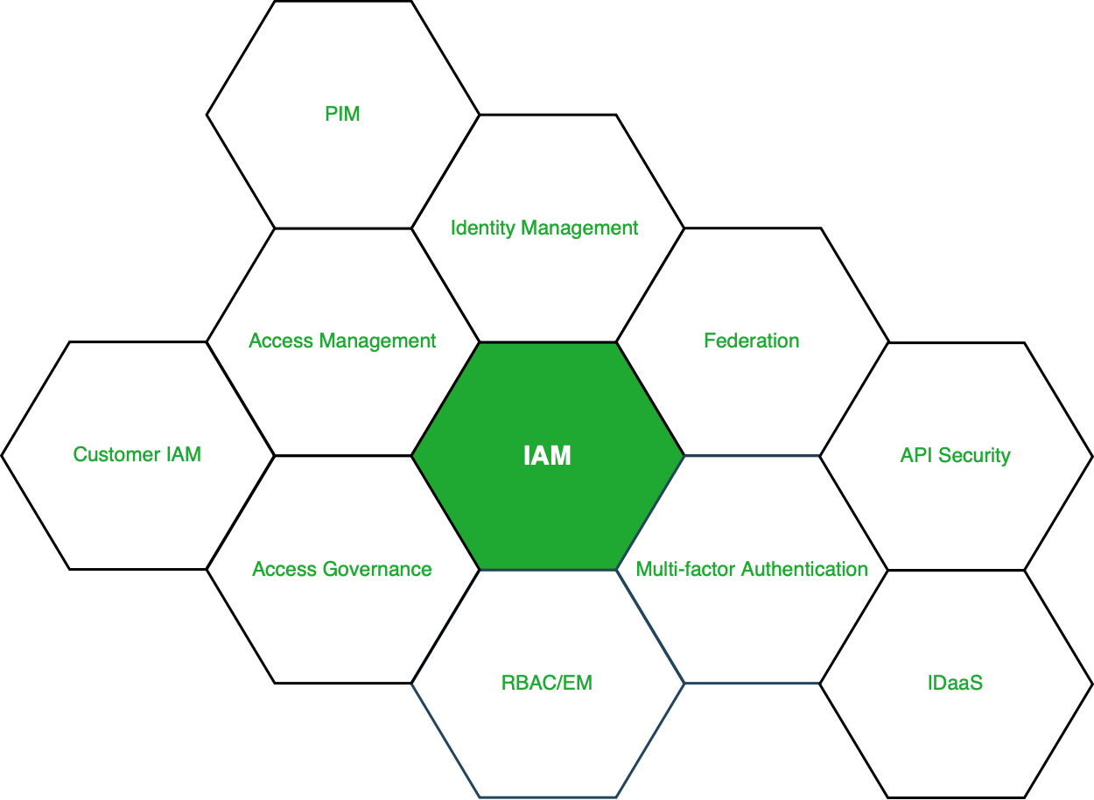

**Figure –** Services under IAM

**More About the Services:** Looking into the services on brief, Identity management is purely responsible for managing the identity lifecycle. Access management is responsible for the access to the resources, access governance is responsible for access request grant and audits. PIM or PAM is responsible for managing all the privileged access to the resources. The remaining services either help these services or help in increasing the productivity of these services.

**Market for IAM:** Current situation of the market, there are three market leaders (Okta, Saipoint and Cyberark) who master one of the three domains (Identity Management, Identity Governance and Privilege access management), according to Gartner and Forrester reports. These companies have developed solutions and are still developing new solutions that allow an organization to manage identity and its access securely without any hindrances in the workflow. There are other IAM tools, Beyond Trust, Ping, One login, Centrify, Azure Active Directory, Oracle Identity Cloud Services and many more.

**Disaster recovery in cloud computing**

Cloud-based backup and retrieval capabilities help you to back-up and reestablish business-critical directories if they are breached. Thanks to its high adaptability, cloud technologies allow efficient disaster recovery, irrespective of the task's nature or ferocity. Data is kept in a virtual storage environment designed for increased accessibility. The program is accessible on availability, enabling companies of various sizes to customize Disaster Recovery (DR) solutions to their existing requirements.

Cloud disaster recovery (CDR) is simple to configure and maintain, as opposed to conventional alternatives. Companies no longer ought to waste a lot of time transmitting data backups from their in-house databases or hard drive to restore after a tragedy. Cloud optimizes these procedures, decisions correctly, and information retrieval.

Cloud Disaster Recovery (CDR) is based on a sustainable program that provides you recover safety functions fully from a catastrophe and offers remote access to a computer device in a protected virtual world.

When it comes to content DRs, maintaining a supplementary data center can be expensive and time taking. CDR (Cloud disaster recovery) has altered it all in the conventional DR (Disaster recovery) by removing the requirement for a centralized system and drastically reducing leisure time. Information technology (IT) departments can now use the cloud's benefits to twist and refuse instantly. This leads to faster recovery periods at a fraction of the price.

As corporations keep adding system and software apps and services to their day-to-day procedures, the associated privacy concerns significantly raise. Crises can happen at any point and maintain a company decimated by huge information loss. When you recognize what it can charge, it is evident why it makes good sense to establish an information restore and retrieval plan.

Disaster recovery data shows that 98 percent of the surveyed companies signify that a couple of hours of leisure time can charge their corporation more than $100,000. Any quantity of rest time can cost the organization 10 of thousands to hundreds and thousands of person-hour workers expended recovering or redeploying missed productivity.

An 8-hour leisure time screen can pay up to $20k for a small business and tens of millions for large companies in certain instances.

Given the estimates, it is apparent why every second of assistance or structure disruption counts data and the real benefit of containing a crisis management plan.

## **How is cloud disaster management working?**

Cloud disaster recovery is taking a very differentiated perspective from classical DR (Disaster recovery). Rather than stacking data centers with Operating system technology and fixing the final configuration used in manufacturing, cloud disaster recovery captures the whole server, including the OS, apps, fixes, and information, into a separate software package or virtual environment.

The virtual server is then replicated or supported to an off-site server farm or rolled to a remote server in mins. While the virtual server is not hardware-dependent, the OS, apps, flaws, and information can be moved from one to another data center much quicker than conventional DR methodologies.

## **How could Rackware assist you?**

Rackware evolves cloud management technology that helps businesses relocate implementations, offer additional disaster recovery and fallback, and cloud storage management.

The RackWare Management Module (RMM) offers Information systems adaptability to companies by streamlining disaster recovery and fallback to any server. Several of the features are discussed as follows:

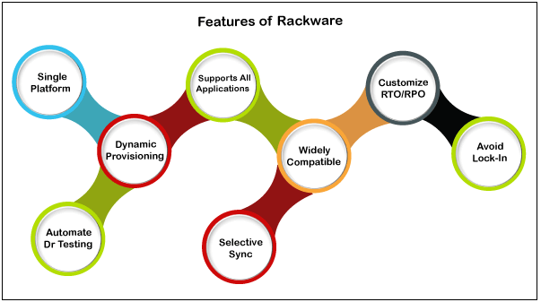

* **Single framework**

It is a single centralized solution that enables replication, sync, integration, cloud-based disaster healing.

* **Widely compatible**

It endorses all physical, digital, and web environments, Hyper-v and cloud atheist load.

* **Endorses all apps**

It promotes all apps, their information, and setup without rewriting any implementations.

* **Prevent lock-in**

Rackware decreases the risk and seller bolt assistance for physical-cloud, data center, and even cloud-physical restore and tragedy retrieval irrespective of supplier.

* **Automatic disaster recovery testing**

Trying down disaster recovery testing helps the company decrease time and labor costs by up to 80 percent from auto DR statistical techniques.

* **Personalize the RTO/RPO**

Provides flexibility to personalize RPO, RTO, and expense priorities as per business requirements through various pre-provisioned or adaptive methods.

* **Dynamic provisioning**

Dynamic procurement considerably reduces the cost of providing Disaster recovery event servers rather than pre-provisioning: this does not use computed assets until failure occurs.

* **Selective synchronization**

Selective sync enables a set of policies, security, and priorities of mission-critical applications and file systems.

## **Cloud disaster recovery methodologies**

Recognize the cloud disaster recovery providing scalability. It must be protecting specific information, apps, and other assets while also accommodating added resources as required and providing sufficient efficiency as other international customers utilize the facilities. Recognize the disaster recovery content's security needs and ensure that the vendor can offer authentication, VPNs (virtual private networks), cryptography, and other toolkits are required to protect it's vital resources.

Ultimately, suggest how the DR system should be designed. There are three basic DR strategies: warm, cold, and hot. These concepts are vaguely connected to how easily a structure can be healed.

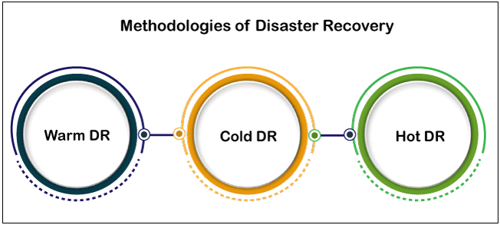

* **Warm disaster recovery**

Warm disaster recovery is a reserve strategy in which copy data and systems are stored with a cloud DR vendor and regularly updated with services and information in the prior data center. However, the redundant assets aren't doing anything. When a disaster happens, the warm DR can be implemented to capability approach from the DR vendor, which is usually as simple as beginning a Virtual machine and rerouting Domain names and traffic to the DR assets. Although recovery times might be pretty limited, the secured tasks must still experience some leisure time.

* **Cold disaster recovery**

Cold disaster recovery usually entails storing information or VMware virtual (VM) pictures. These resources are generally inaccessible unless added work is performed, such as retrieving the stored data or filling up the picture into a Virtual machine. Cold DR is typically the easiest (often just memory) and absolute cheapest method. Still, it requires a long time to regain, leaving the organization with the most leisure time in the event of a disaster.

* **Hot disaster recovery**

Hot disaster recovery is traditionally described as a real-time simultaneous implementation of information and tasks that run concurrently. Both the primary and backup data centers execute a specific tasks and information in sync, with both websites communicating a fraction of the entire data packets. When a disaster happens, the residual pages continue to handle things without interruption. Consumers should be unaware of the disturbance. Although there is no time for rest with hot DR, it is the most complex and expensive methodology.